INTERNSHIP ASSIGNMENT 2

**STUDENT DATABASE**

CREATE TABLE Person_table(PersonID int,FirstName varchar(255),descriminator varchar(255));

insert into person_table values('1','lokesh','student');

insert into person_table values('2','lokesh','student');

insert into person_table values('3','guru','student');

insert into person_table values('4','sarguru','student');

insert into person_table values('5','arun','student');

insert into person_table values('6','yokesh','student');

insert into person_table values('7','mukesh','student');

insert into person_table values('8','gurunath','student');

insert into person_table values('9','sar','student');

insert into person_table values('10','varun','student');

**select * from person_table;**

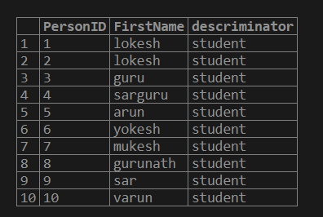

create table Student_grade(id int,course varchar(20),grade decimal(3,2));

insert into student_grade values('1','mysql','7.0');

insert into student_grade values('2','sql','1.0');

insert into student_grade values('3','java','6.0');

insert into student_grade values('4','json','5.0');

insert into student_grade values('5','.net','4.0');

insert into student_grade values('6','c','3.0');

insert into student_grade values('7','python','2.0');

insert into student_grade values('8','dbms','2.0');

insert into student_grade values('9','aws','1.0');

insert into student_grade values('10','lws','8.0');

**select * from student_grade;**

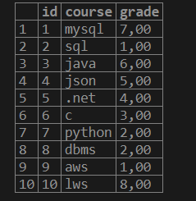

select ( select firstname from person_table p where p.personid=s.Id) as Name , s.course,s.grade from student_grade s where ID IN (select p.personID from person_table p where p.personid=s.Id) ;

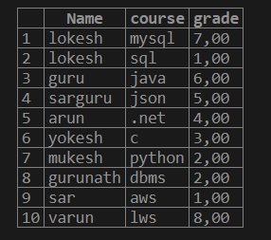

select TOP 5 ( select firstname from person_table p where p.personid=s.Id) as Name , s.course,s.grade from student_grade s where ID IN (select p.personID from person_table p where p.personid=s.Id) order by s.grade desc;

